**Exercises Sequence**

**Exercise 1**

Write a program that retrieves the user's personal data and then prints the address label.

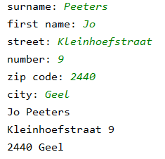

When printing, use the + operator and then try without the + operator.

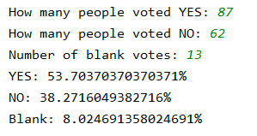**Exercise 2**

Write a program that allows a user to convert the results of a vote into percentages.

The user enters the number of Yes votes, the number of No votes and the number of blank votes.

The program shows the percentage of each type of vote.

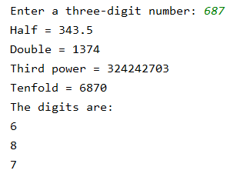**Exercise 3**

Write a program that reads a 3-digit number and prints the following information.

Do not use string functions to find the separate digits.

**Exercise 4**

Write a program to read 2 names and then change places in memory and print them again.

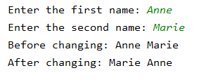

**Exercise 5**

Write a program to convert an amount in Euro into Dollar. You first have to read the current exchange rate.

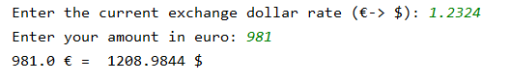

**Exercise 6**

Write a program that allows you to repeat a word on the screen. You let the user choose a text and the number of times the text will be repeated.

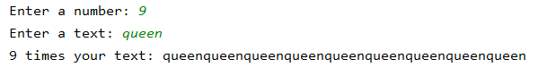

**Exercise 7**

Write a program to generate the next output. The number 15 is fixed. The other numbers should be calculated by using operators += -= *= etc. So use only 1 variable.

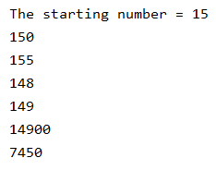

**Exercise 8**

Write a program that allows a user to know what time his alarm will go off when he indicates what time it is (only the hour is entered) and how long he wants to wait.

For example:

* It's 14:00 and he wants to wait 8 hours. the alarm will go off at 22:00
* It's 9:00 and he wants to wait 20 hours. the alarm will go off at 5:00

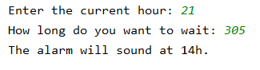

**Exercise 9**

Write a program that helps you calculate the number of degrees Fahrenheit (Tf) when you enter the temperature in degrees Celsius (Tc). Use this conversion formula between Tc and Tf :



**Exercise 10**

Electricity companies charge their customers a fixed annual amount of € 83.6 (connection, meter rental, maintenance, ...).

At night you pay 0,035 € / kilowatt per hour. During the day you pay 0,068 €/ kilowatt per hour.

On top of that, the customer also has to pay 21% VAT.

Create a program that calculates how much you have to pay. First the customer has to enter his data (power consumption is always a whole number).

Then the customer gets an overview of his account.

